Joomla Installation
Download:
Download the joomla 1.5 version and extract the full-package file.
Rename:
Rename the file (Ex:joomla).
Save and open:
Save and open the file from your local host (Ex: http://localhost/joomla).
Installation
There are 7 steps for joomla Installation.
Step 1: Language:-
To check default value for US-English Language from select box. Then click Next Button.
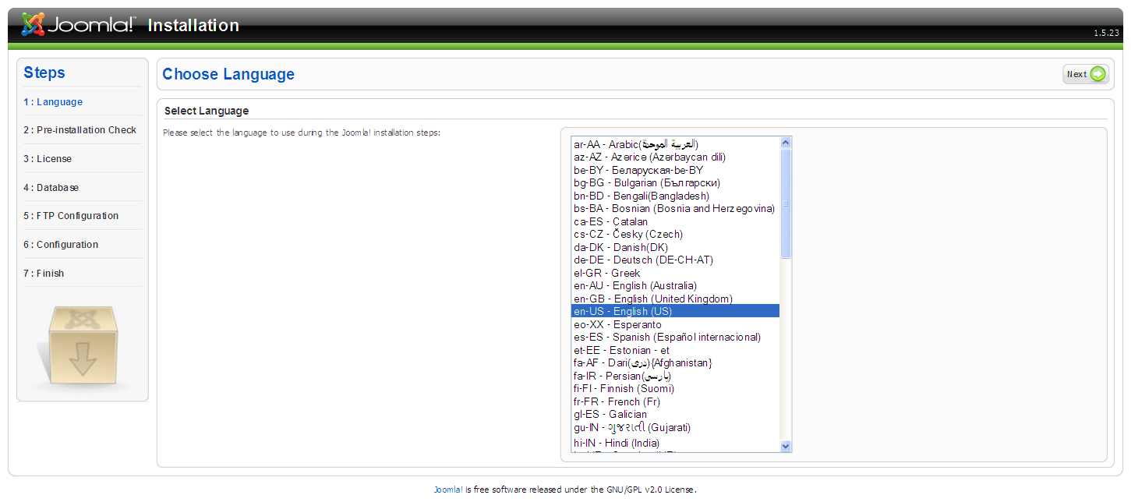
Step 2: Pre-Installation Check:-
Check all data’s from pre-Installation and recommended settings . Then click Next Button.
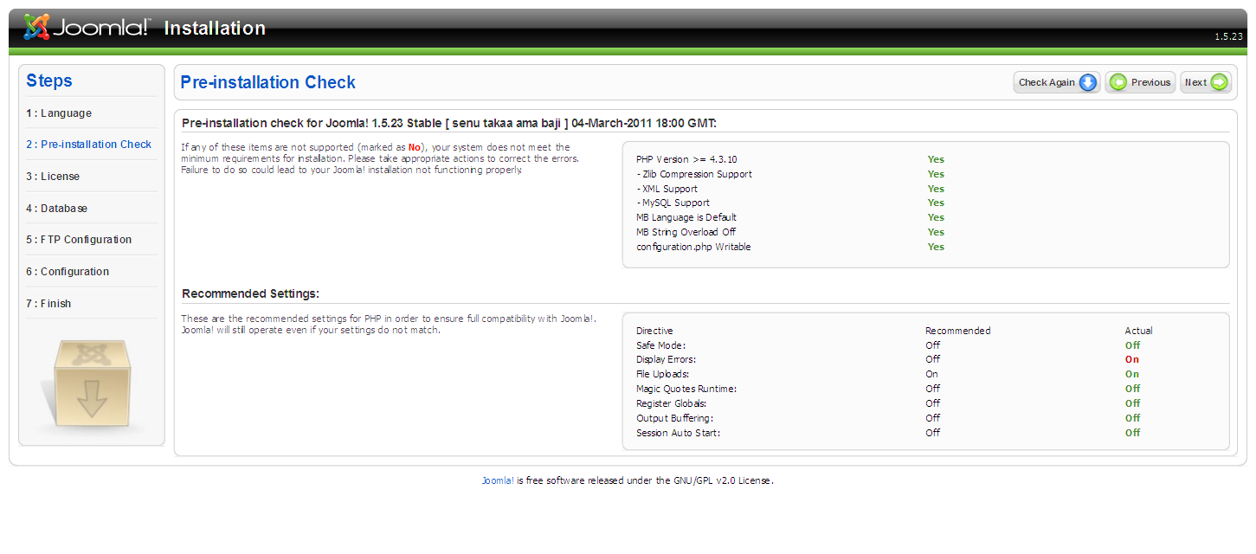
Step 3: License:-
There are no changes from this page so click Next Button.
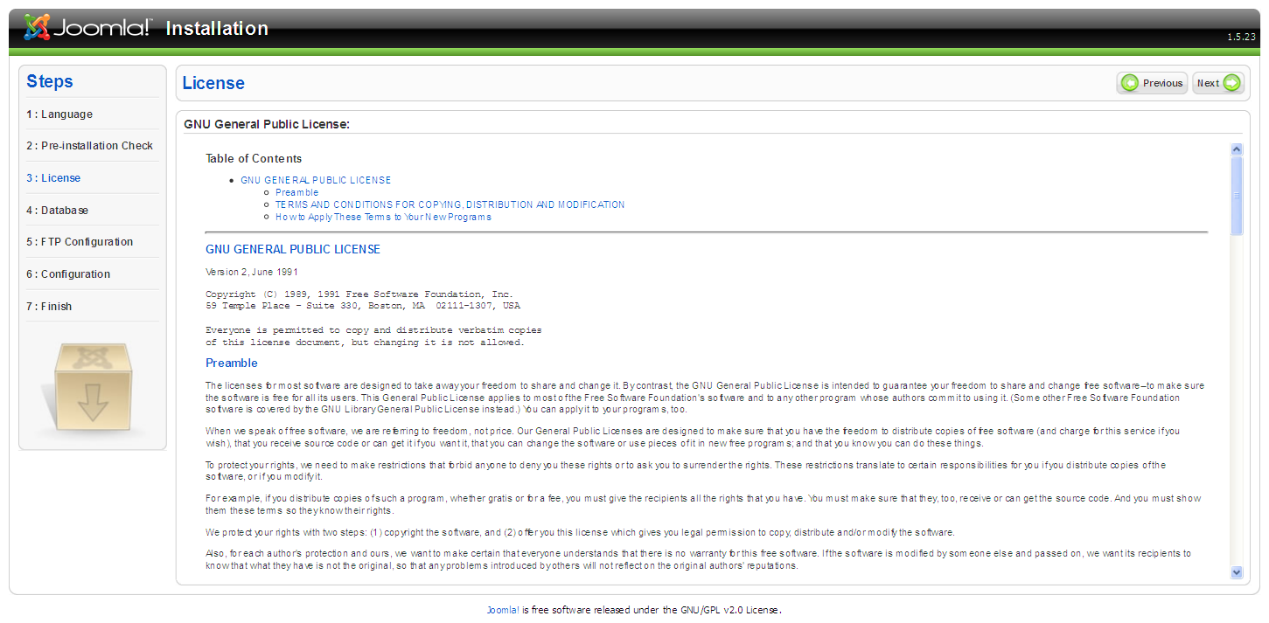

Step 4: Database Configuration:-
Go to the basic settings:
Database type: to check default value for mysql.
Host Name: localhost.
User Name: root ( default mysql username).
Password: empty or your wishes.
Database Name: your database name (EX: Joola 1.5).
Then click Next Button.
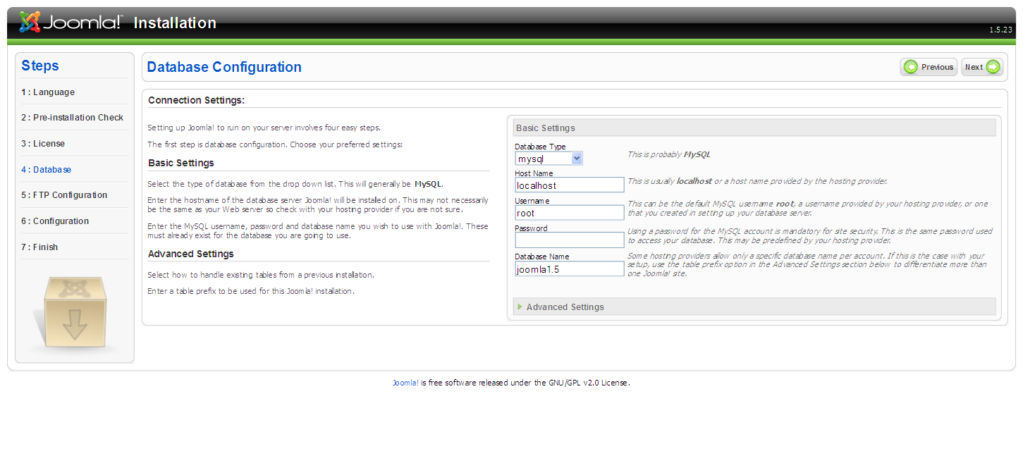
Step 5: FTP configuration:-
Go to the basic settings:
Enable FTP file system layer->Select No button. Then click Next Button.
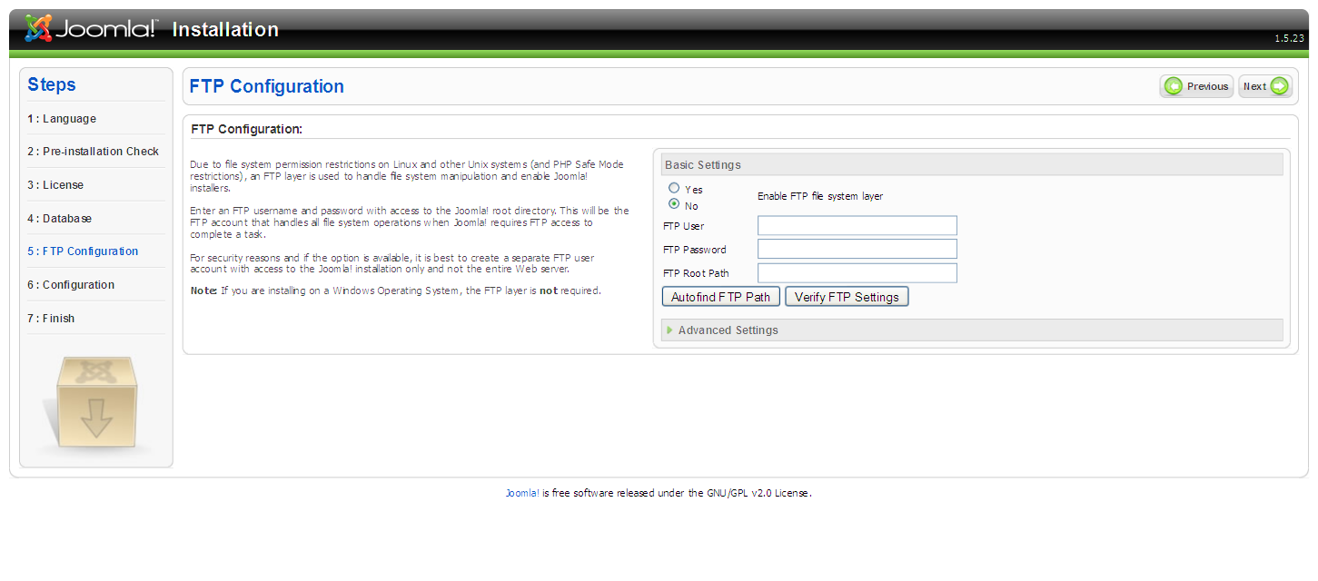
Step 6: Main configuration:-
Site Name: Enter the name of your Joomla! site. (EX: my practice website).
Your E-mail: Your email address (Ex: dhanapal.hideaz@gmail.com).
Admin Password: admin (this password easy to remember).
Confirm Admin Password: admin.
If you want sample data, click Install Sample Data. Then click Next Button.
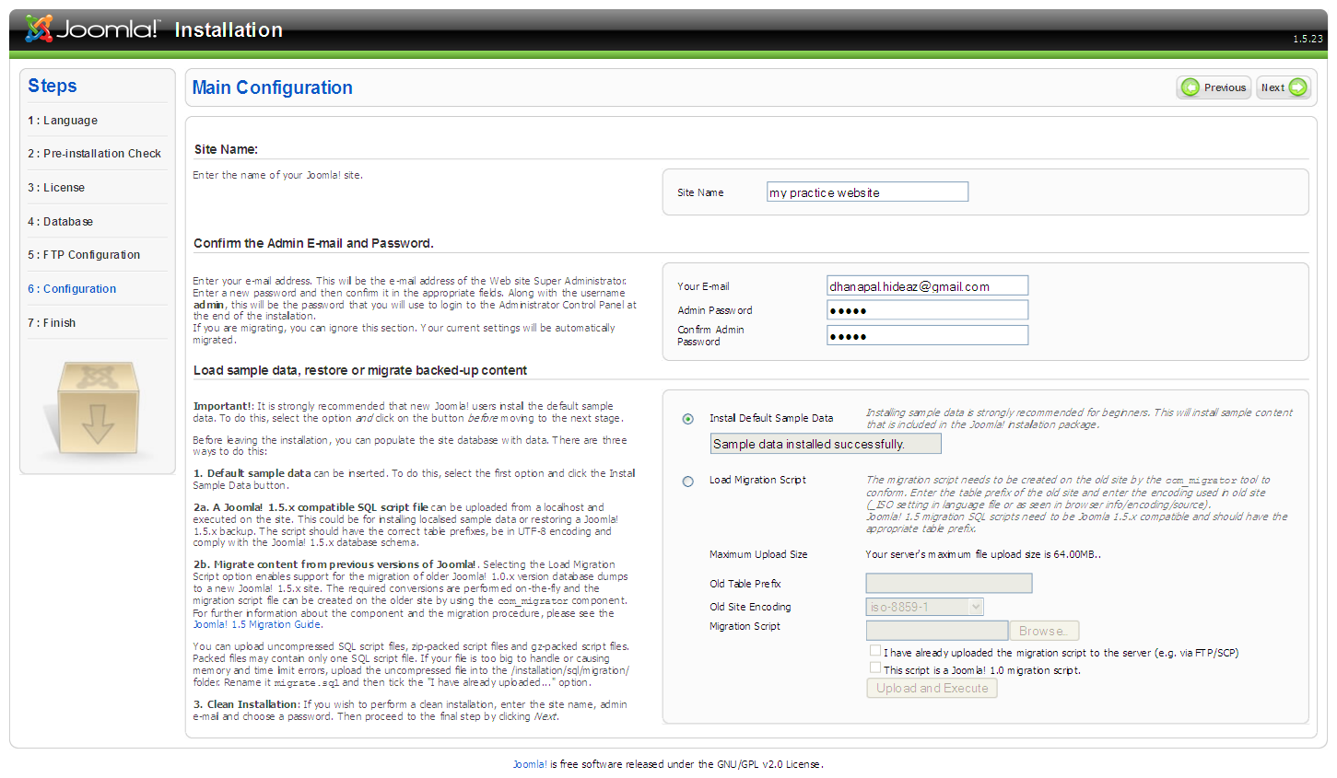
Step 7: Finish:-
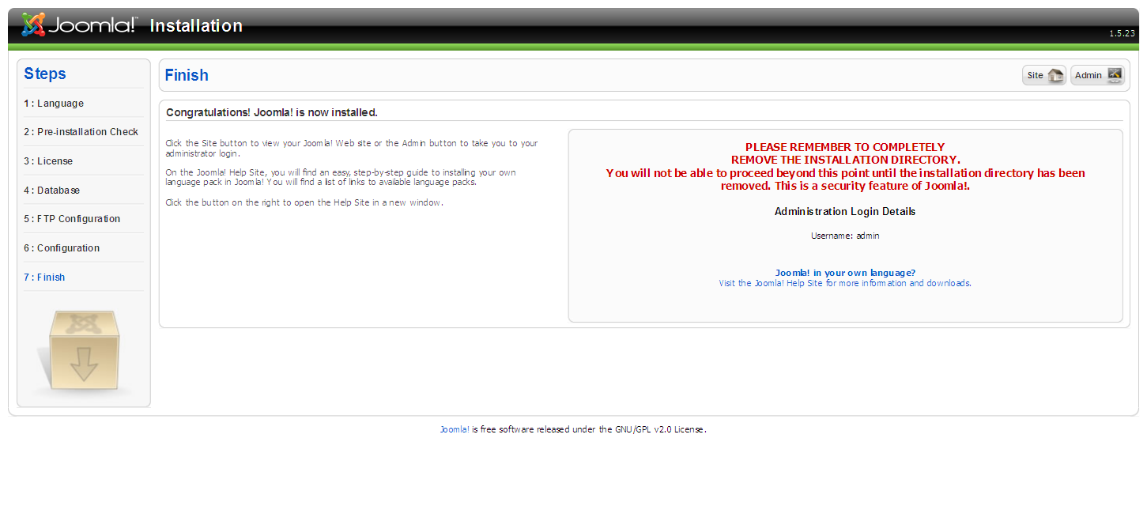
Delete the installation folder from localhost/joomla(your site name). Then click site or admin page

